**Rainfall Outlook User Manual**

**Table of Contents (English)**

1. Getting the App
   1. Downloading the App
   2. Installing the App
   3. Opening the App
2. Updating the App
   1. Downloading the Update
   2. Installing the Update
3. Using the App
   1. Selection of Province
   2. Selection of Municipality
   3. Six Month Nationwide Rainfall Outlook
   4. Agritip
   5. App Pages
   6. About
4. **Getting the App** (*Pagkuha ng App*)

**Step 1. Download the app.** This can be done through three ways.

1. **QR Code.** Use a QR code scanner for the download.

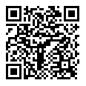

1. **Link.**

<https://build.phonegap.com/apps/3371430/download/android>

1. **Google Play Store** *(*not yet available)*

**Step 2. Install the App.** Go to your phone’s “My Files” > “Downloads” and then click the Apk file.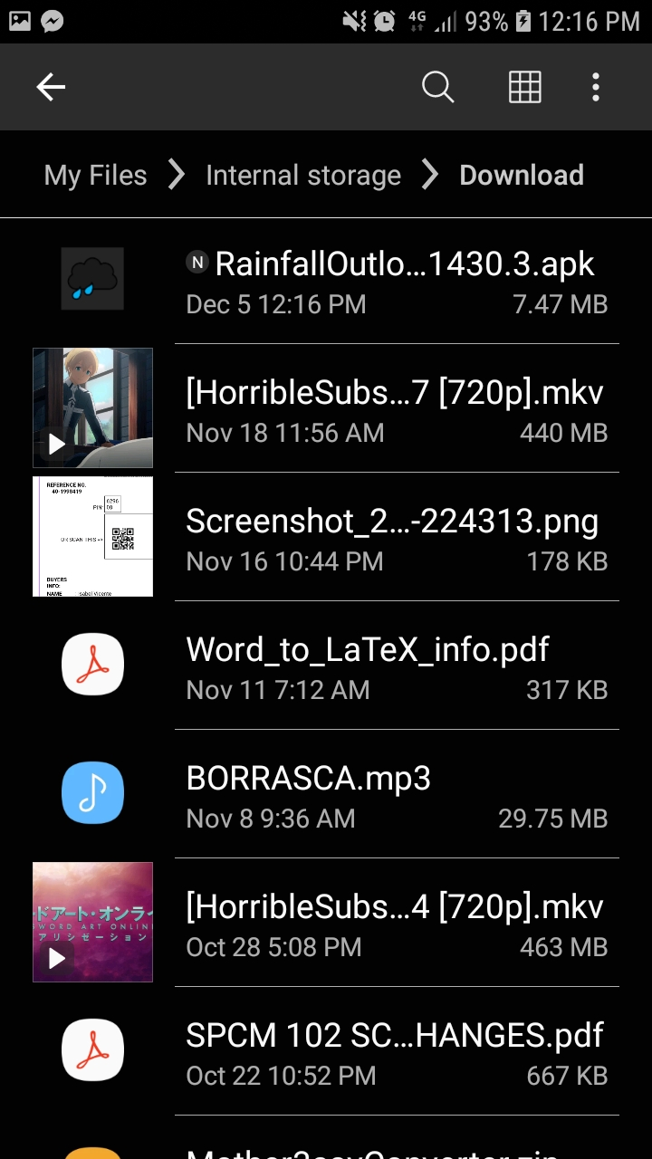

.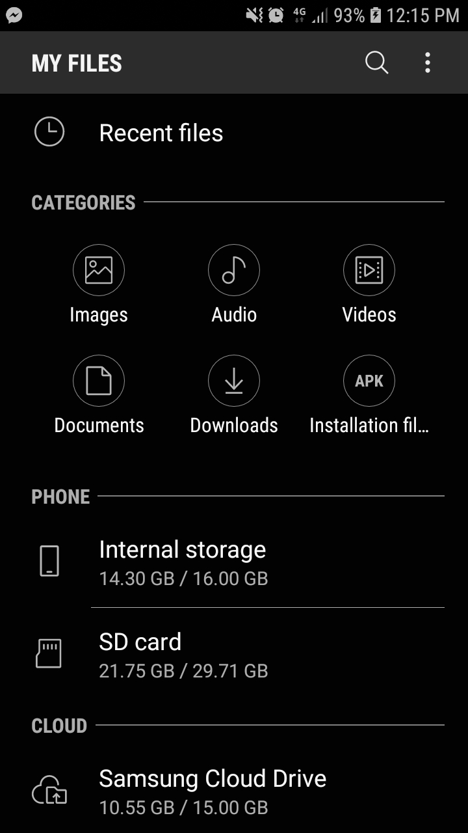

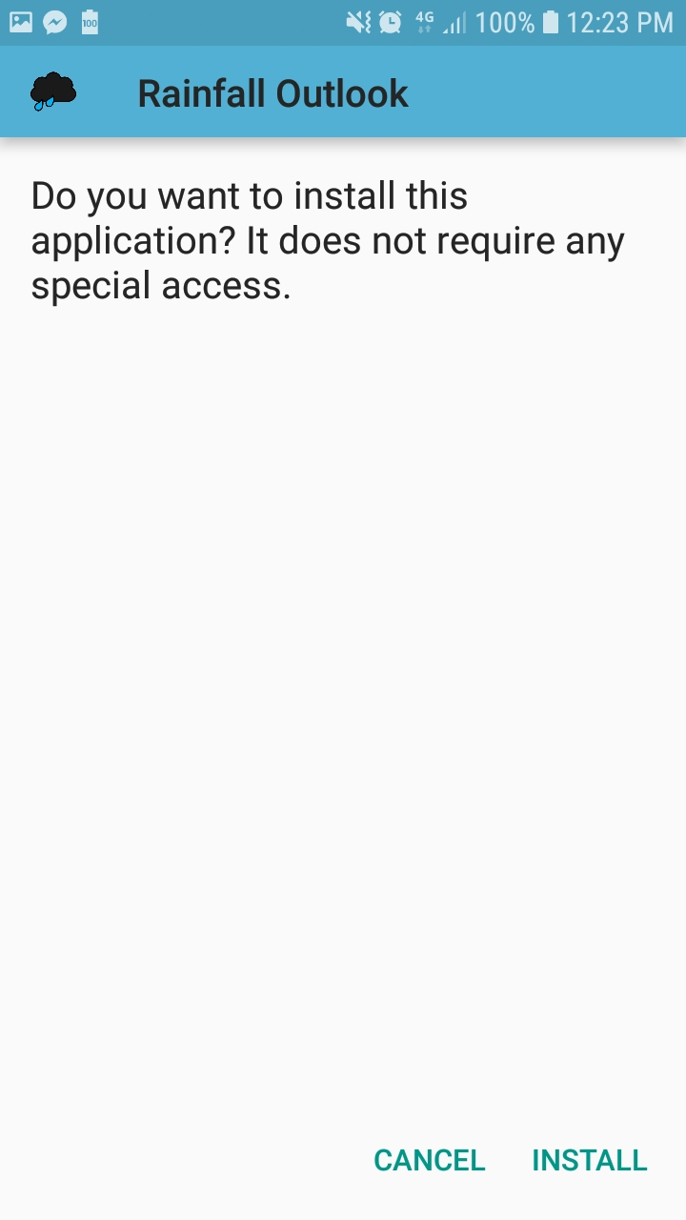

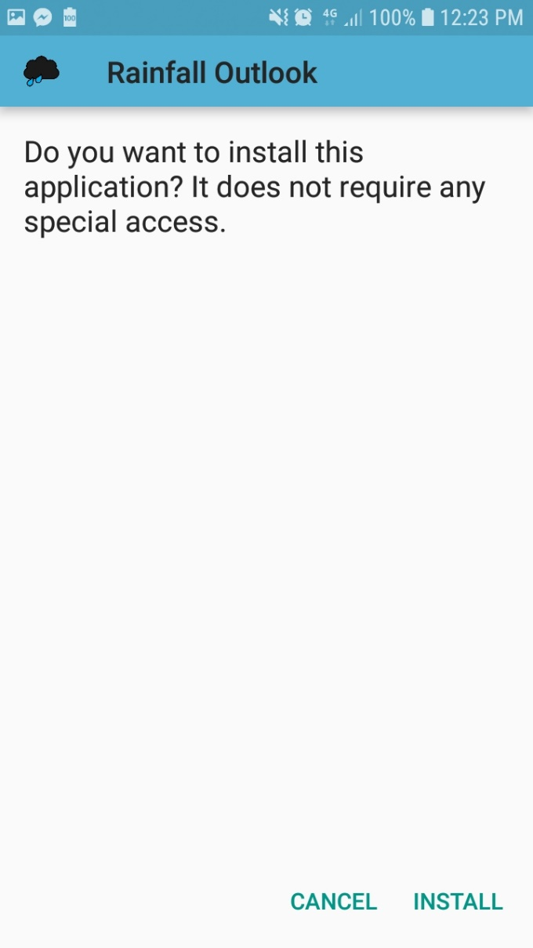

You will see this screen, just wait for it

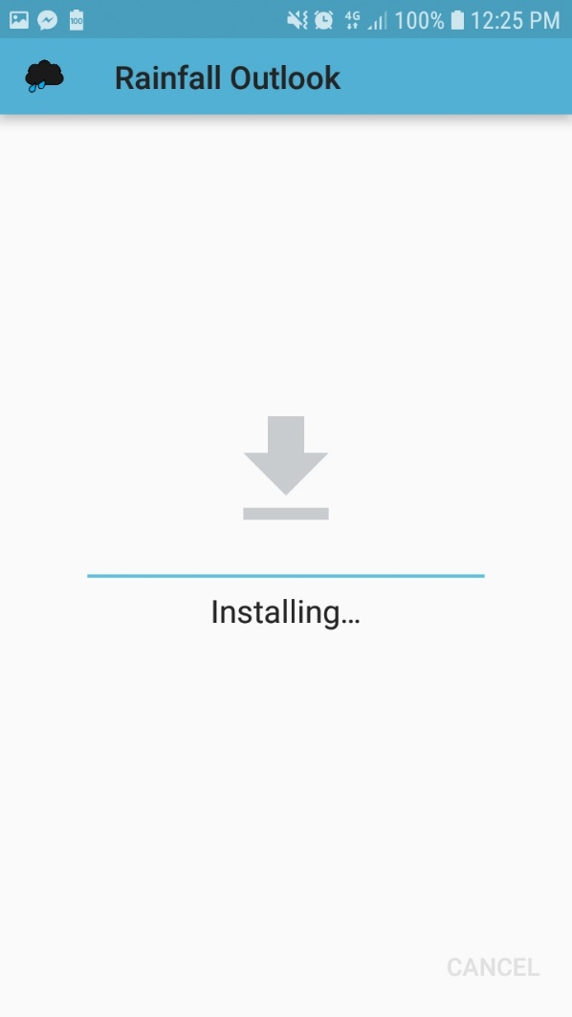

After installation, the system will prompt if you want to open the app immediately after. If you wish to open it, click “**OPEN**”.

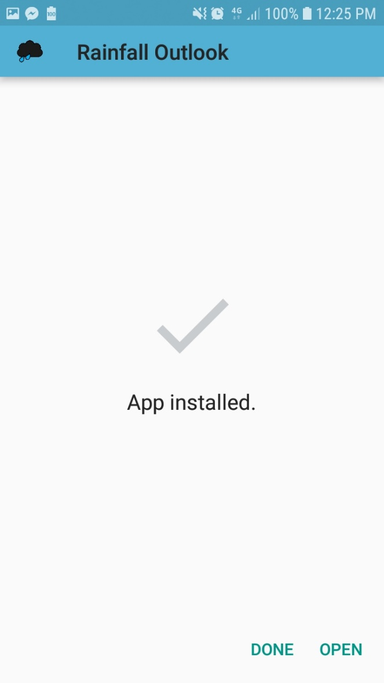

If you don’t, and click done, you will find the app in your apps screen or your home screen.

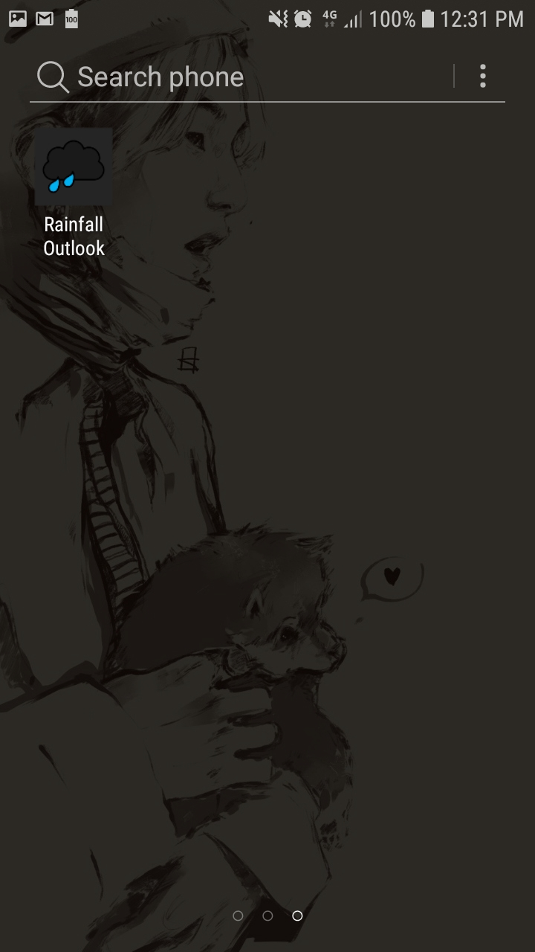

(apps screen)

1. **Updating the App** (*Pag-update ng App*)

**Step 1. Download the update.** This can be done through three ways.

(*This has the same steps as installing the app.*)

1. **QR Code.** Use a QR code scanner for the download.



1. **Link.**

<https://build.phonegap.com/apps/3371430/download/android>

1. **Google Play Store** *(*not yet available)*

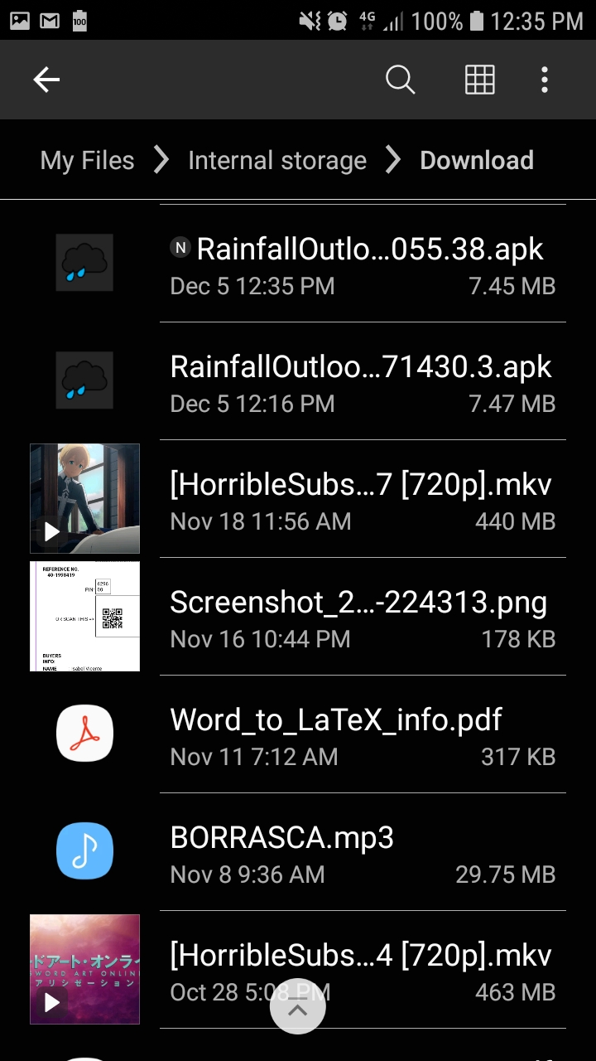**Step 2. Install the Update.** Go to your phone’s “My Files” > “Downloads” and then click the Apk file.



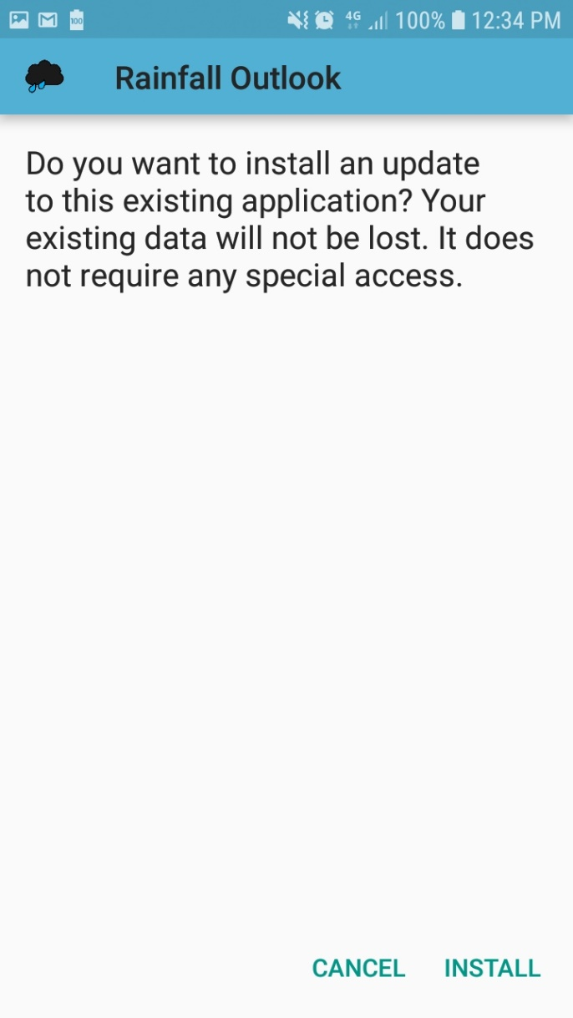

You will see this screen, just wait for it

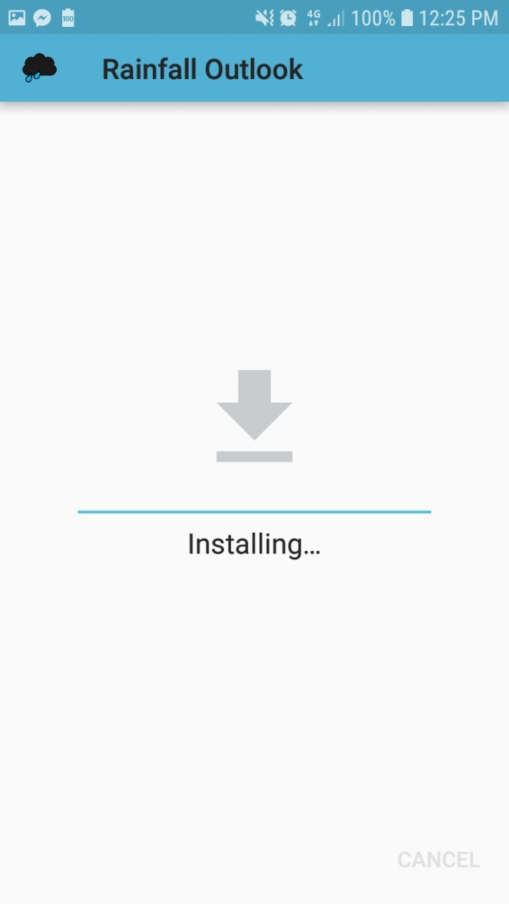

After installation, the system will prompt if you want to open the app immediately after. If you wish to open it, click “**OPEN**”.



If you don’t, and click done, you will find the app in your apps screen or your home screen.



(apps screen)

1. **Using the App (Paggamit ng App)**
   1. Selection of Province and Municipality

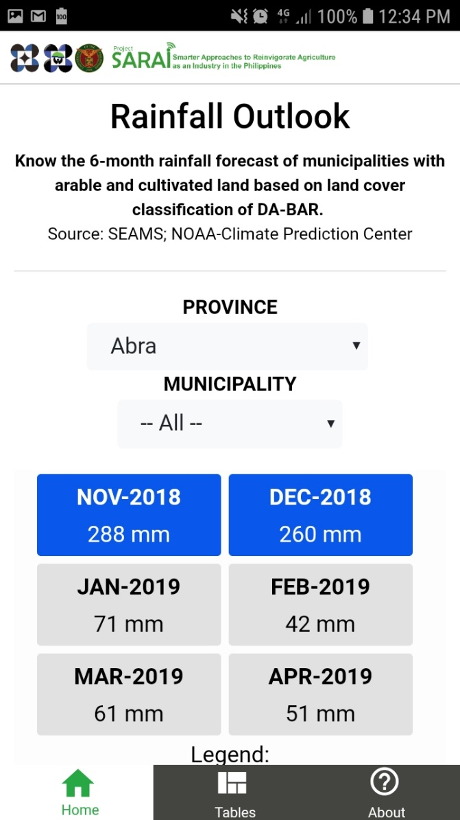

Selecting a Province will show the Rainfall Outlook of the next six months in the display below the dropdowns.

* 1. Selection of Municipality



Selecting a Municipality will show the Municipality’s Rainfall Outlook of the next Six Months.

Selecting “--All--" in the Municipality dropdown will show the Rainfall for the entire province.

* 1. Six Month Nationwide Rainfall Outlook

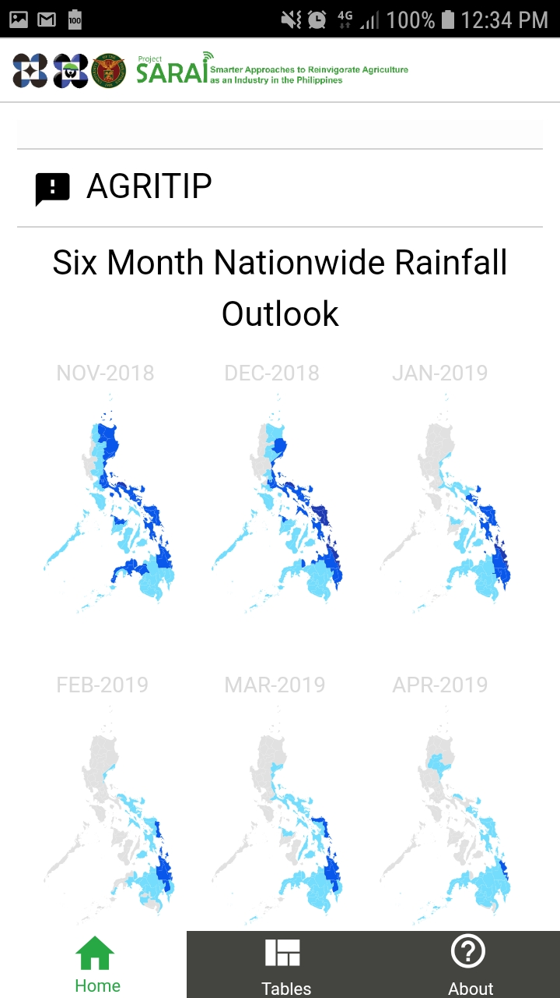

* 1. App Pages

**HOME**

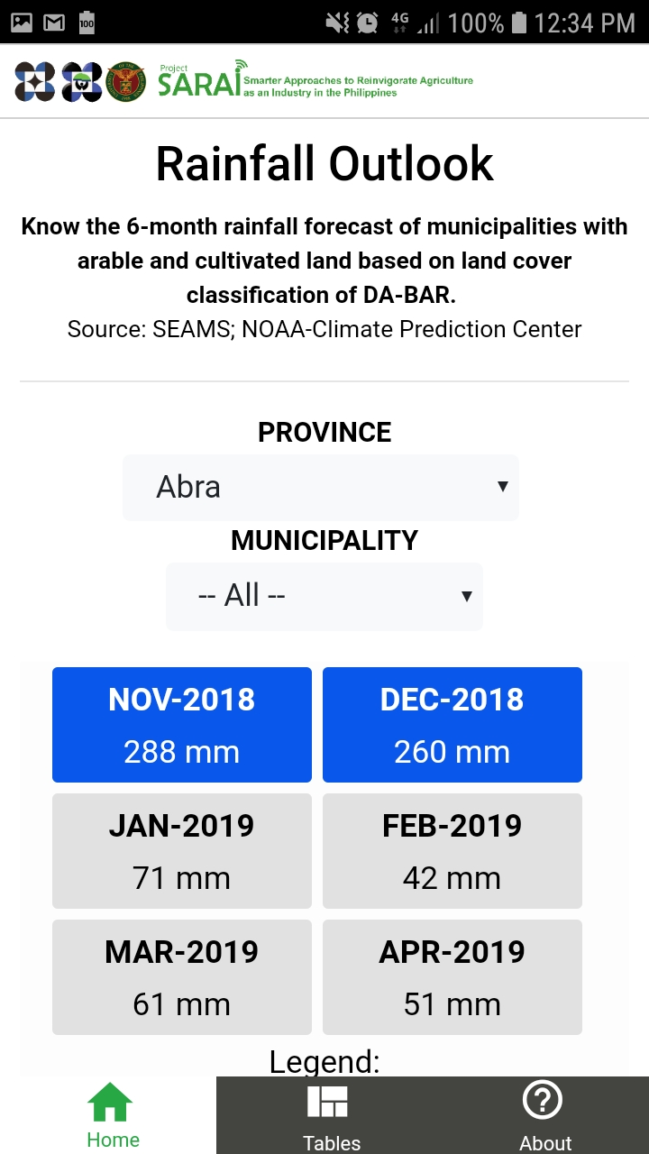

**TABLES**

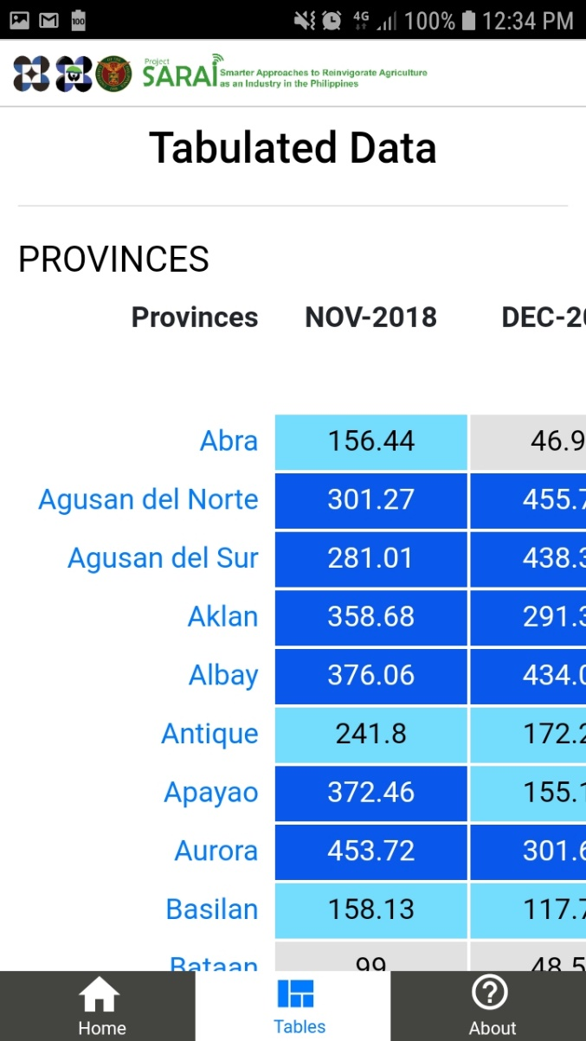

Clicking on the name of a province will change the display to that specific province.

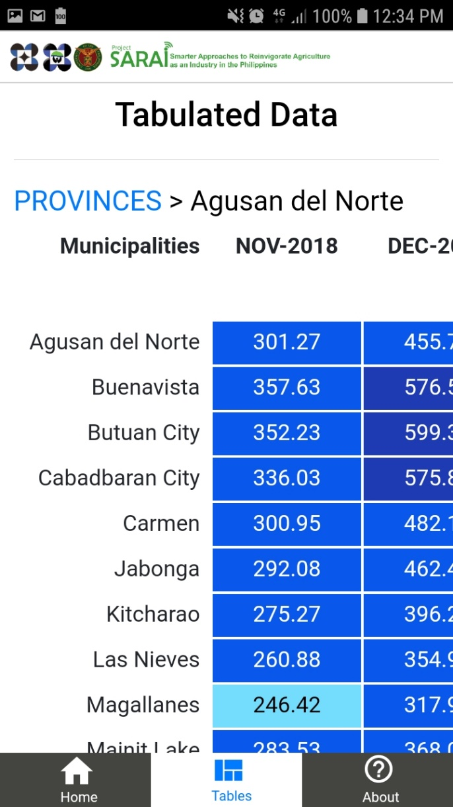

Clicking on “PROVINCES” will make the tables show all the provinces.

ABOUT

